**Investigation of the morphological, physiological and biochemical change of *Ceratodon purpureus* to desiccation and well-watered conditions.**

**ABSTRACT**

*Ceratodon purpureus* is a dioicous, acrocarpous moss in the family Ditrichaceae with a cosmopolitan distribution across all continents. Desiccation tolerance is a ability to loss almost all the water content in the plant(95•/•).In this paper we have studied about the desiccation tolerance ability of the plant *Ceratodon purpureus* which was identified and taken from Devarayana durga hills . Here we studied the biological , morphological and biochemical response of the moss by subjecting it to the hydration, dehydration and rehydration state. The relative water content (RWC) of the moss which was 100•/• in the hydrating state dropped to 6.4•/• after drying for 4hrs but regained up to 79.8•/• of RWC upon rehydrating. The effect of desiccation on the moss has caused the rapid reduction in total chlorophyll content and a significant increase in carotenoids, anthocyanins, proline, and lipid peroxidation which shows the defence mechanism of the moss towards the oxidative stress. Upon rehydration the moss regained it’s most of the physiological and morphological characters including the proline and chlorophyll content to their initial level which Indicates the moss ability to recover rapidly of its morphological characters. Overall in our research we highlight our findings about the desiccation tolerance of *Ceratodon purpureus*. The DT ability of the moss appears to be depend on rapid shifts in antioxidant activity and osmolyte accumulation. Based the information acquired by we can conclude that the *Ceratodon purpureus* can be a useful model for understanding the DT in the bryophytes.

**INTRODUCTION**

Desiccation tolerance (DT) is the ability to withstand almost a complete loss of water (around 95%). DT plants have capability to survive after drying to a water content of 0.1 g H2O g−1 dry mass or less (Alpert and Oliver, 2002). DT is a conspicuous trait found in several groups of organisms, including bacteria, fungi, algae, lichens, bryophytes, ferns, and vascular plants; it is also present in some phyla of animals, including rotifers, nematodes, and tardigrades (Alpert, 2006). Capacity to resist desiccation has been suggested to be essential for the ancestral adaptation of plants to terrestrial life (Oliver et al., 2000), but with the development of conducting tissues and roots, desiccation tolerance was partially lost due to the advantages of water conducting strategies, allowing plants to be larger, structurally more complex, and with higher metabolic rates. Plant lineages that have lost organism-level desiccation tolerance have often maintained it for their spores, pollen, or seeds (Gaff and Oliver, 2013). In some cases, the ability to tolerate desiccation has independently reappeared in the evolution of different groups and on different occasions, proving to be an advantageous quality for adaptation to and survival in novel harsh environments Bryophytes are known to inhabit a broad variety of terrestrial habitats, ranging from cold and hot deserts to the tropics, commonly employing desiccation tolerance as a successful life strategy (Proctor and Tuba, 2002).

DT plants are divided to poikilohydric and homoiohydric type. Poikilohydric plants, which include bryophytes, which lose almost all chlorophyll pigment under desiccation to reduce the generation of reactive oxygen species. These plant unable to actively regulate their water content, which therefore varies with the humidity of the environment. In rehydration stages plant synthesis, the chlorophyll pigment in de-novo manner (Proctor and Tuba, 2002). In contrast, homoiohydric plants maintain some amount of chlorophyll pigment in desiccation state (Proctor and Tuba, 2002). Consequently, organisms with a poikilohydric strategy are subjected to higher fluctuations of water content, while those with a homoiohydric strategy have mechanisms to avoid desiccation and tolerate partial dehydration (Proctor and Tuba, 2002).

One of the most remarkable features of bryophytes is their ability to dry up without dying. In most terrestrial habitats, the gametophytes of many mosses and some liverworts regularly dry to equilibrium with the air, often losing virtually all their free water, and then resume normal growth after rehydration by rainfall or dew. The ability to tolerate desiccation is not unique to bryophytes, but they are the only major group of plants and one of only two groups of macroscopic organisms in which desiccation tolerance (Proctor et al., [2007](https://pmc.ncbi.nlm.nih.gov/articles/PMC9314017/#ppl13661-bib-0061)).

DT in bryophytes is important, which has already led to advances in medicine and may lead to improvements in agriculture (Alpert 2005). Bryophytes show at least as much diversity in their DT as would be expected from the diversity of their habitats. Bryophytes are known to inhabit a broad variety of terrestrial habitats, ranging from cold and hot deserts to the tropics, commonly employing desiccation tolerance as a successful life strategy (Proctor and Tuba, 2002).

The extremes of tolerance are found in the species of exposed, arid ground and rock surfaces, which must bear not only extreme dryness but the unabated rays of the sun (ref). Epiphytic bryophytes of the branches and the forest-canopy are in general more tolerant of rapid and frequent drying, and of more severe desiccation (Franks & Bergstrom 2000; Hosokawa & Kubota 1957; Tobiessen et al. 1979). Bryophytes species of constantly moist and shady places are typically the least tolerant to desiccation, but there are probably few that cannot tolerate short periods of relatively mild desiccation, at least seasonally (Franks & Bergstrom 2000). Submerged aquatics can tolerate short periods of drying out when water levels are low, and some mosses of the flood zone (e.g., *Cinclidotus fontinaloides, Schistidium rivulare*) grow submerged when water levels are high but are highly DT when they are exposed in summer (Hosokawa & Kubota 1957; Tobiessen et al. 1979).

Although bryophytes are generally considered to be desiccation-tolerant, there is still a large intra- and interspecific variability, and studies have reported contrasting effects of key climatic characteristics on the functioning of different bryophyte species (Van Wijk et al., 2004; Elmendorf et al., 2012; Lang et al., 2012). Furthermore, a broad taxonomic analysis of desiccation tolerance has highlighted major gaps in understanding of the causes of such variability in bryophyte Eco physiological stress responses (Marks et al., 2021).

DT plant can tolerate the extreme water loss and regain their whole physiological metabolic activity at well-watered conditions with minimum damage. In desiccation stress plant lose its 90% of water. That induces the generation of superoxide radical, and extreme oxidative stress that can leads to the death of the plant. DT plants have innate ability to tolerate effect of desiccation. DT plant strategically exhibits antioxidant enzyme activity (both enzymatic and non-enzymatic), accumulation of proline, sucrose, anthocyanins and other protective proteins to tolerate desiccation (Proctor et al., [2007](https://pmc.ncbi.nlm.nih.gov/articles/PMC9314017/#ppl13661-bib-0061)).

*Ceratodon purpureus* is a dioicous, acrocarpous moss in the family Ditrichaceae with a cosmopolitan distribution across all continents (McDaniel & Shaw, 2005). *C. purpureus* is often found growing in urban environments, poor soils, and recently burned areas, and evidently is tolerant of a wide range of environmental conditions including soils laden with heavy metals. For many years *C. purpureus* has been used a model to study physiology, population genetics (McDaniel et al., 2007), and sexual ecology (Rosenstiel et al., 2012). Along with the recent effort to sequence its genome and an increasing understanding of its general ecology, *C. purpureus* is increasingly becoming a robust model system for studying community dynamics in the bryosphere. In this paper we analyse the morphological, physiological and biochemical change of *C. purpureus* to desiccation and well-watered conditions.

**MATERIALS And METHODS**

**1.Sample collection and identification:**

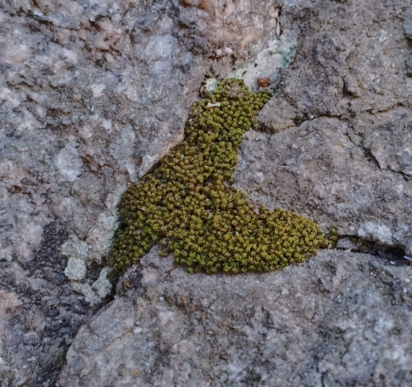 Ceratodon purpureus samples were collected from Devarayanadurga Hills (13 23'N 77 13'E 850-1290 Mts above MSL) during monsoon. Ceratodon purpureus habitat on an inselberg, under a tree canopy. Fresh specimens were transported to the laboratory in sterile polythene bags. Soil was carefully removed by rinsing the samples with running tap water. The cleaned plants were stored for further analysis under the appropriate conditions. The species was identified as Ceratodon purpureus based on the criteria described by the British Bryological Society (Ref) for the identification of mosses and other bryophytes based on its morphological and cellular characteristics under magnification.

TWO more pictures - habitat

**Experiment set up**

The samples of *Ceratodon. purpureus* were collected from the hills of Devarayanadurga and brought to the laboratory using a polythene bag. The soil from the sample was removed. A total of 5grams of the sample was weighed. This is labelled as the hydrated state of *C. purpureus*. The hydrated state sample was kept at room temperature to check on the desiccation state. The weight of the Desiccated state of C.purpureus was constant after 180 minutes. This desiccated sample was kept in water to check the rate of rehydration capacity of Ceratodon purpureus. The weight of the sample came at a constant rate at 150 minutes.

This was noted as the rehydration state of the *C. purpureus*. The hydration, desiccation, and rehydration states were noted, and the RWC was calculated. The respective hydrated, desiccated, and rehydrated samples were ground into fine powder using liquid nitrogen under aseptic conditions. The fine powder samples were stored in an air-tight container to carry out various tests.

**2. Relative Water Content estmation**

The fresh, healthy sample of Ceratodon purpureus was weighed 5 grams and recorded as Fresh weight. The sample was kept to desiccate at room temperature until the weight was constant and listed as Dry weight. The samples were later subjected to rehydration to check on the capacity of restoration of water absorption and noted as Turgid weight when the weight of the sample weighed constant. The period to attain the constant weights was recorded. The formula to calculate RWC is as follows,

RWC (%) = [(FW − DW) / (TW − DW)] × 100

where, RWC= Relative Water Content, FW= Fresh Weight, DW= Dry / Desiccated Weight,TW= Turgid Weight.

The samples at every stage were ground into a fine powder using liquid Nitrogen and stored in airtight container for further assays. This approach helps in preserving biochemical integrity. (Ref)

**3. Estimation of Chlorophyll and Carotenoids**

To determine the total chlorophyll and carotenoid content in Ceratodon purpureus, 0.01 grams of samples of each hydrated, desiccated and rehydrated stage were taken. The tissues were extracted using 15 ml of 80% acetone and incubated overnight in darkness (to avoid pigment degradation). After incubation, samples were subjected to centrifugation at 7000 rpm for 5 minutes. The supernatant was collected for the assay. Absorbance was recorded at 663.6 nm and 645.6 nm against the blank using a spectrophotometer (Bio spectrophotometer, Eppendorf CA(USA)). The concentrations of chlorophyll a, chlorophyll b, and total chlorophyll were calculated using the following equations:

Chlorophyll a= 12.7 × A663 – 2.59 × A645  
Chlorophyll b = 22.9 × A645 – 4.7 × A663  
Chlorophyll (a+b) = 8.2 × A663 + 20.2 × A645

Carotenoid= 1000×A470−1.82×Chl a−85.02×Chl b/198  
Results were expressed in mg-1g FW for chlorophyll and for Carotenoids in mg-1ml-1gFW.

**4. Quantification of Proline**

To quantify the proline content in the hydration, desiccated and rehydrated stages of Ceratodon purpureus, 0.01 grams of samples of each stage were taken. The samples were then homogenized in 1 ml of 3% sulfosalicylic acid and incubated over 72 hours. The mixture was then centrifuged at 7,000 rpm for 10 minutes at 4°C The supernatant was collected. to the supernatant, the following, 0.2 ml of 96% acetic acid, 0.2 ml ninhydrin, and 0.1 ml ninhydrin reagent were added, and subjected to incubation in a boiling water bath for one hour. on cooling the mixture to room temperature, 1 ml of toluene was added, and the absorbance was measured at 520 nm against the blank using the spectrophotometer (Bio spectrophotometer, Eppendorf CA(USA)). Proline concentration was calculated and expressed in µ mol g-1 FW.

**5. Quantification of Anthocyanin**

Anthocyanin content in Ceratodon purpureus was quantified at hydrated, desiccated and rehydrated stages each. 0.01 g of plant samples at respective stages was extracted using 20 ml of a methanol: water: HCl mixture taken in the ratio of 80:20:1, v/v/v. The samples were incubated in darkness (to avoid pigment degradation) for 48 hours. After incubation, the mixtures were centrifuged at 7,000 rpm for 15 minutes at 4°C, and then the supernatant was collected. Absorbance readings were taken at 530 nm and 657 nm against the blank using the spectrophotometer (Bio spectrophotometer, Eppendorf CA(USA)). Total anthocyanin content was calculated using the following formula:  
Total Anthocyanin = (A530 – 0.3 × A657) × V / M where, V =extract volume (ml), and M=sample mass (g). The quantity of anthocyanin was expressed in mg-1 ml-1 g FW.

**6. Quantification of Lipid Peroxidation**

To quantify Lipid peroxidation in Ceratodon purpureus was done by measuring malondialdehyde (MDA) content. 0.01 grams of each sample of hydrated, desiccated, and rehydrated stages was homogenized in 2 ml of 0.25% thiobarbituric acid (TBA), prepared using 10% trichloroacetic acid. The mixture was heated in a boiling water bath at 95°C for 30 minutes. On cooling, centrifugation at 10,000 rpm for 10 minutes was carried out. The supernatant was collected, and absorbance was measured at 532 nm and 600 nm against the blank using the spectrophotometer (Bio spectrophotometer, Eppendorf CA(USA)). Lipid peroxidation was expressed as nmolg-1FW using an extinction coefficient of 155 mM⁻¹cm⁻¹. The MDA concentration was calculated as:  
Concentration of MDA (mM) = (A532 – A600) / 155 × 1000

**Super Oxide Radical Estimation**

0.01 g of fully hydrated, desiccated and rehydrated sample was ground with 100 mM

potassium phosphate buffer – pH 7.2. The homogenate was centrifuged at 6000 rpm

for 5 mins. 500 μl of 2 mM NBT and incubate for 10 mins, then add 2 ml of 1.4

Dioxin to the above mixture and incubate for 15 mins in a boiling water bath at 70°C, then centrifuge at 2000 rpm for 10 mins. The OD of the supernatant was

measured at 540 nm. O2- was expressed as μmol/g FW (U. S. et al., 2021).

**7. Quantification of 0Antioxidant enzymes activity.**

The whole *Ceratodon purpureus* plant was completely hydrated, desiccated, and then rehydrated in order to test various antioxidant enzymes, notably peroxidase (POD), catalase (CAT) and superoxide dismutase (SOD). For the SOD, CAT, and POD Assay

**7.1 Superoxide dismutase (SOD).**

Superoxide dismutase (SOD) activity determination in Ceratodon purpureus was done by taking 0.01grams sample of hydrated, desiccated and rehydrated stages each in 6 ml of extraction buffer,50 mM phosphate buffer (pH 7.0). The mixture was centrifuged at 15,000 rpm for 20 minutes at 4°C. The supernatant was collected and labelled as the enzyme extract. the reaction mixture was prepared by the addition of 10 mM methionine, 1 mM riboflavin, 1 mM NBT, 1 mM EDTA, and 100 μl of the enzyme extract. After incubation of 15 minutes, the absorbance was measured at 560 nm against the blank using the spectrophotometer (Bio spectrophotometer, Eppendorf CA(USA)). SOD activity was expressed in units-1 mg protein U. S. et al., 2021) and calculated using the following formula:  
SOD unit/ml = (v/u – 1) × Dilution factor

where v= absorbance of the control, u= absorbance of the sample.

**7.2 Catalase (CAT).**

To measure the Catalase (CAT) activity in  Ceratodon purpureus , 0.01 g hydrated,desiccated and rehydrated sample were mixed with 5 ml of extraction buffer made of 50 mM phosphate buffer (pH 7.0) under cold conditions. Themixture was subjected to centrifugation 10,000 rpm for 10 minutes at 4°C to get supernatant recorded as the enzyme extract. 2.9 ml of hydrogen peroxide (H₂O₂) was mixed with 0.1 ml of enzyme extract, and the absorbance was recorded at 240 nm against the blank using the spectrophotometer (Bio spectrophotometer, Eppendorf CA(USA)). CAT activity was expressed as units-1 mg protein and calculated using the following:  
Catalase activity (unit/ml) = (ΔA₅ – ΔA₀) × 3 × Dilution factor / (Extinction coefficient of H₂O₂ × amount of enzyme in aliquots)

where ΔA₅ and ΔA₀ represent the change in absorbance at 5 minutes and 0 minutes, respectively.

**7.3 Peroxidase (POD).**

Peroxidase (POD) activity was determined in Ceratodon purpureus using 0.01 grams of respective hydrated, desiccated and rehydrated samples mixed with extraction buffer made of 50 mM phosphate buffer (pH 7.0). On centrifugation at 7000rpm for 10 min, the supernatant was collected named enzyme extract. 5% pyrogallol, 30% hydrogen peroxide (H₂O₂), and 0.1 ml of enzyme extract were made into a mixture. The absorbance was measured at 420 nm against the blank using the spectrophotometer (Bio spectrophotometer, Eppendorf CA(USA)) . The results were expressed in µ mol-1 min-1 mg protein and calculated using the following formula:  
Peroxidase activity (Unit/ml) = (ΔA₅ – ΔA₀) × 3 × Dilution factor / (extinction coefficient × amount of enzyme aliquots)

where ΔA₅ and ΔA₀ represent the change in absorbance at 5 minutes and 0 minutes, respectively.

**8. Estimation of Starch.**

Starch content in Ceratodon purpureus was calculated by subjecting 0.01 grams of samples of hydrated, desiccated and rehydrated stages respectively with 2 ml of 80% ethanol at 80°C for 30 minutes under agitation. Centrifugation was done at 2000rpm for 10 minutes. The pellet was collected and washed twice with 1 ml of 80% ethanol and then resuspended in 1 ml of water. The suspension was kept in a boiling water bath for 15 minutes. 100 μl of the mixture was incubated overnight at 30°C with the mixture of 25 units of glucoamylase in 50 mM acetate buffer (pH 4.5). Soluble glucose, which was released from the hydrolysis of starch was quantified using the dinitro salicylic acid (DNS) method. with concentrations determined from a glucose standard curve. Starch content was expressed as m µ mol g-1 FW (Cuellar-Ortiz et al., 20__).  
Starch content (mg) = (Sample OD / Standard OD) × Standard glucose amount (mg).

**RESULTS**

**1. Relative Water Content (RWC).**

Hydrated plants of Ceratodon purpureus were subjected to desiccation, which led to the reducing their relative water content from 100% to just 6.382% in 4 hours of air drying at room temperature. On rehydration, water content was restored to 78.90%, which matched nearly about to the original hydrated state. The tissues regained their initial morphology upon rehydration, which demonstrates the high capacity of water recovery and structural resilience. These results highlight the plant’s ability to withstand severe desiccation and rapidly recover upon water availability.

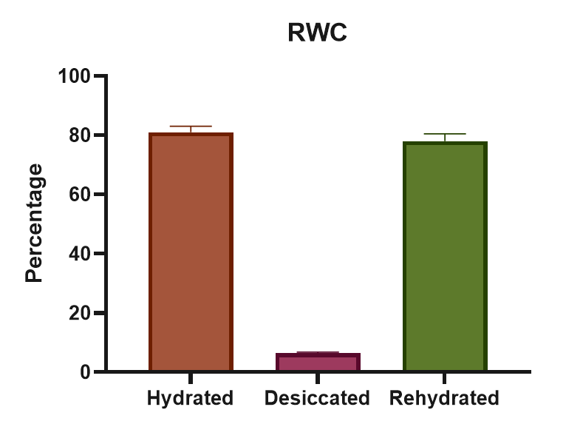

**2. Total Chlorophyll and Carotenoid Concentration**

It was discovered that the total chlorophyll content (Chl a+b) in the hydrated stage was 13.1938 mg-1g FW, whereas in the desiccated stage 2.564 mg-1g FW. The drop in the value resulted in the loss of all of the Chlorophyll, that was present in the hydrated condition. The chlorophyll concentration of the rehydrated stage increased to 11.2812 mg-1g FW, suggesting that rehydration restored the Chlorophyll content.

The content of carotenoids was measured to be 0.022mg-1ml-1gFW in the Hydrated stage, which increased to 0.04898 mg-1ml-1gFW in the Desiccated stage and then recovered to 0.01533 mg-1ml-1gFW in the Rehydration stage.

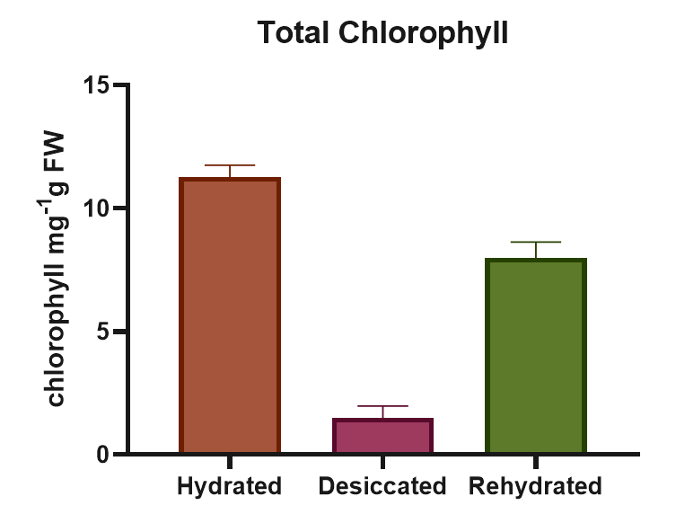 Our findings show that the overall Chlorophyll and carotenoid Concentration of Ceratodon purpureus varied significantly bet ween the Hydrated, Desiccated and Rehydrated stages.

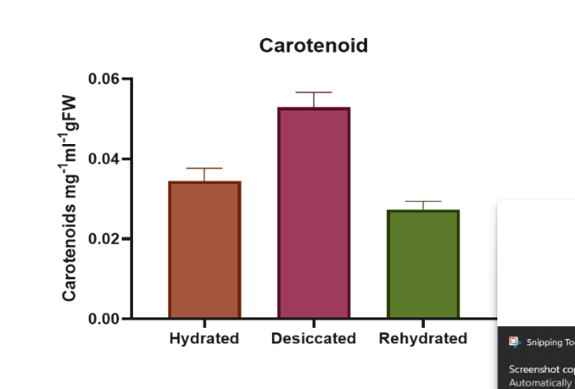

**3. Anthocyanin concentration**

It was observed that the anthocyanin content was 0.2552 mg-1 ml-1 g FW in the Hydrated stage, rising to 1.1740 mg-1 ml-1 g FW in the desiccated stage, and then decreasing to 0.1905 mg-1 ml-1 g FW in the Rehydrated stage, values that were lower than those of the hydrated tissues in rehydrated tissues.

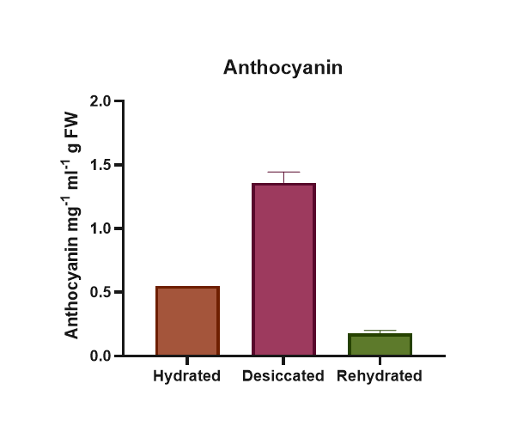

**4. Proline concentrations**

Proline concentration in the Hydrated, Desiccated and Rehydrated stages of Ceratodon purpureus was expressed in terms of in µ mol g-1 FW. n hydrated stage it was 0.0616 μmol/g FW, then was increased to 0.342 in µ mol g-1 FW in the desiccated stage, and it was almost regained to its original concentration, that is 0.0536 in µ mol g-1 FW. The results revealed a large increase in proline at the dried stage, suggesting that proline functions as an osmolyte.

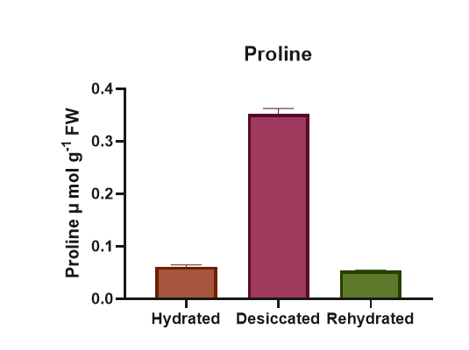

**5. Lipid peroxidation**

In Hydrated, Desiccated, and rehydrated stages, the concentration of lipid peroxidation, measured as malondialdehyde (MDA) content, was 0.0451 nmolg-1FW, 0.240 nmolg-1FW, and 0.0387 . we observed that lipid peroxidation levels increased in desiccated stage when compared hydrated stage and the gradually decreased in the rehydrated stage

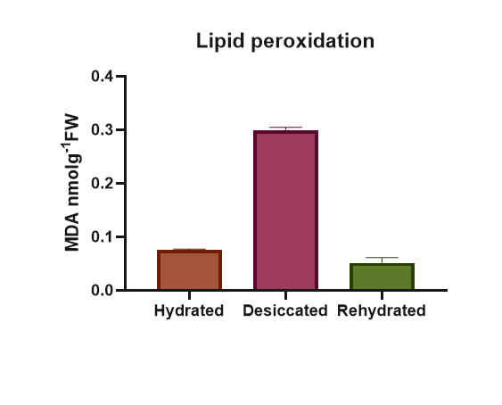

**Superoxide radicals estimation**

The concentration of superoxide radicals is measured. In Hydrated-Stage, it was found to

be 0.7003 nmolg-1 FW, whereas in desiccation-Stage, it was increased to 0.966 nmolg-

1 FW, and in rehydration, it was found to be 0.488nmolg-1 FW.

**6. Antioxidant Enzyme Activities**

The antioxidant enzymes SOD, CAT, and POD in hydrated, desiccated, and rehydrated stages of Ceratodon purpureus. In comparison to hydration and rehydration, the enzyme activity increased during the desiccated stage. Diese Reaktion demonstrates how strong antioxidant-enzyme activity guards against physiological harm to the cell brought on by the generation of ROS as a result of desiccation.

**6.1 Superoxide dismutase (SOD)**

Superoxide dismutase (SOD) activity in *Ceratodon purpureus*, the concentration of SOD increased from 0.7266 units mg-1 protein in Hydrated stage to 1.277 units mg-1 protein in Desiccated stage and 0.172 units mg-1 protein in Rehydrated stage

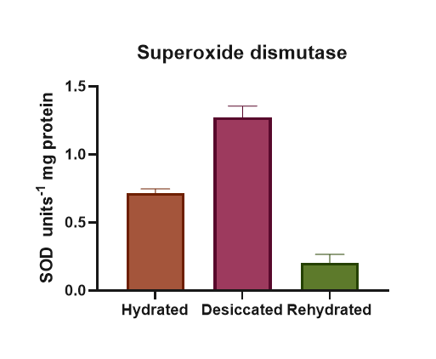

**6.2 Catalase (CAT)**

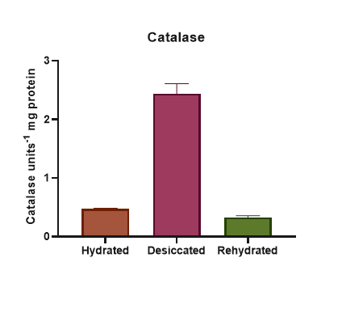In *Ceratodon purpureus*, Catalase (CAT) activity was elevated in the Desiccated stage compared to other antioxidant enzymes studied; the trend was comparable. It was discovered that the hydrated stage was found to be 0.4722 units/mg Protein, but it increased to 3.817 units/mg Protein in the desiccated stage. And in the rehydrated stage, it was found to be 0.422 units/mg protein.

**6.3 Peroxidase (POD)**

In *Ceratodon purpureus*, peroxidase (POD) activity was found to be 0.742 μ mol-1 min-1mg protein in hydrated stage and increades in desiccated stage to 1.218 μ mol-1 min-1mg protein. Gradually the value at the rehydrated stage was seen 0.673 μ mol-1 min-1mg protein.

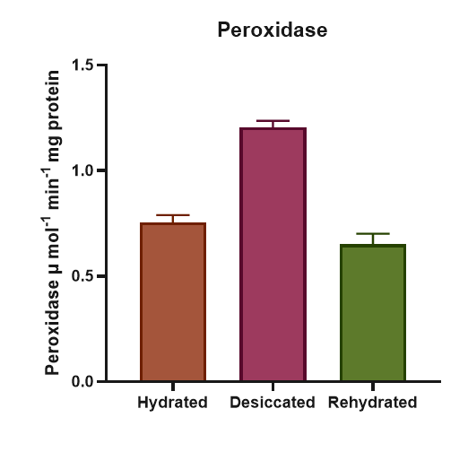

**7. Starch concentration**

Starch concentration in *Ceratodon purpureus* was highest in the hydrated stage at 0.532 mg glucose, but declined sharply to 0.2346 mg glucose during desiccation. Upon rehydration, starch content recovered to 0.3795 mg glucose, approaching levels seen in hydrated tissues. These results indicate a significant depletion of starch reserves under desiccation, with substantial restoration following rehydration, reflecting the plant’s dynamic carbohydrate metabolism in response to water stress.

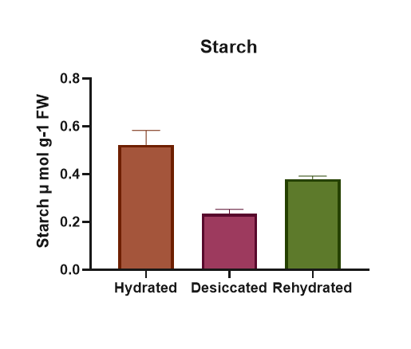

**Discussion**:

Relative water content is an important characteristic that reflects plant water relations and is affected by drought stress(Farooq et al. 2009)(Yang et al. 2021). It is defined as the water content in plant tissues relative to its maximum water-holding capacity(Farooq et al. 2009; Plants and Drought in a Changing Climate | Current Climate Change Reports n.d.).During leaf development, the relative water content of wheat leaves is initially high but decreases as dry matter accumulates and the leaf matures (Farooq et al. 2009).Drought stress significantly impacts relative water content in various plant species (Farooq et al. 2009)(Yang et al. 2021). Water-stressed plants, such as wheat and rice, exhibit lower relative water content compared to non-stressed plants (Farooq et al. 2009).Plants employ various mechanisms to maintain or adjust their relative water content under drought conditions(Farooq et al. 2009). Osmotic adjustment, through the accumulation of solutes, lowers the osmotic potential of cells, attracting water and maintaining turgor. Maintaining high tissue water potential is crucial for drought tolerance, and species vary in their ability to do so. The ability of plants to maintain water-use efficiency by reducing water loss is crucial for drought tolerance(Farooq et al. 2009).

In our study effects of desiccation on *Ceratodon purpureus* was examined using Scanning Electron Microscopy. Morphological changes during *Ceratodon purpureus* hydrated, desiccated and rehydrated states were studied. Our results showed that *Ceratodon purpureus* have open stomata with green coloured turgid leaves, in desiccated state *Ceratodon purpureus* curls its leaves, losses green colour in leaves and closes its stomata, and after rehydration its morphology was restored to its original form. But there were no major significant anatomical changes in its main axis and rhizoids. Fully hydrated *Ceratodon purpureus* sample had RWC of 81%, after subjecting to desiccation for 2.5hr RWC reduced to 6.38% and it restored RWC about 78.9% after rehydration. Our study showed slightly similar results compared to *H. propagulifera* behaviour in hydrated, desiccated and rehydrated states studied in research paper (Ramyashree et al. 2021), where their sample’s RWC decreased to 17% during desiccation and regained 95% of RWC after rehydration.

Chlorophyll, Carotenoid and anthocyanin content:

During desiccation, resurrection plants employ various strategies regarding chlorophyll. Some plants, known as poikilochlorophyllous, degrade chlorophyll and thylakoid membranes to prevent ROS production, while others, called homoiochlorophyllous, retain chlorophyll, enabling quick recovery after rehydration(Farooq et al. 2009; Yang et al. 2021). Homoiochlorophyllous plants minimize ROS production through mechanisms like leaf folding and accumulating anthocyanins(Gechev et al. 2012).In desiccation-tolerant mosses, pigment loss doesn't always occur. However, some studies show chlorophyll loss in species like *Atrichum androgynum* and *Tortula ruralis* during rapid drying cycles. Light exposure can increase desiccation-induced oxidative damage and chlorophyll loss in sensitive mosses, but has less effect on tolerant species(Proctor et al. 2007).

Desiccation tolerant plants utilize photoprotective mechanisms such as thermal energy dissipation and antioxidants to minimize the production of ROS. Non-photochemical quenching (NPQ) of chlorophyll fluorescence is high in DT bryophytes, indicating thermal dissipation of excess energy. In dry conditions, chlorophyll fluorescence is almost completely suppressed in highly DT bryophytes. Carotenoids act as antioxidants, protecting photosynthetic machinery from reactive oxygen species (ROS) that accumulate during dehydration. They help dissipate excess light energy as heat, reducing the risk of photooxidative damage (Proctor et al. 2007).

Anthocyanins are known to accumulate in response to environmental stressors, suggesting a protective role. These pigments contribute to the red, purple, and blue colours in plant tissues and are influenced by light, temperature, and nutrient availability. Under drought conditions, which can lead to desiccation, some plants enhance anthocyanin accumulation as a means of improving tolerance. The protective mechanisms of anthocyanins, such as their antioxidant properties and photoprotection, could indirectly contribute to desiccation tolerance(Li and Ahammed 2023). As antioxidants, anthocyanins can scavenge reactive oxygen species (ROS) that accumulate during stress, including dehydration, thus minimizing oxidative damage. Their role in photoprotection could also be relevant, as desiccation often occurs under high light conditions, and anthocyanins can help protect photosynthetic machinery from damage. The synthesis of anthocyanins is regulated by various transcription factors and environmental cues(Li and Ahammed 2023).

Total chlorophyll content in hydrated, desiccated and rehydrated samples of *Ceratodon purpureus* were estimated, in which the total chlorophyll value decreased from 11.2743 mg-1g FW of hydrated sample to 1.4948 mg-1g FW of desiccated sample and again increased to 7.9885 mg-1g FW after rehydration. Carotenoid content in hydrated sample was 0.0345 mg-1ml-1gFW, which was increased to 0.0529 mg-1ml-1gFW slightly in desiccated sample and reduced to 0.0167 mg-1ml-1gFW in rehydrated sample. Anthocyanin content in hydrated sample was found 0.5233 mg-1ml-1gFW, after desiccation it increased to 1.36 mg-1ml-1gFW and after rehydration decreased to 0.176 mg-1ml-1gFW. In comparison with *H. propagulifera* in the research paper (Ramyashree et al. 2021) the chl a/chl b ratio was high in desiccated sample than hydrated and rehydrated samples of *H. propagulifera.*

Antioxidant mechanism:

Resurrection plants employ diverse antioxidant mechanisms to combat stress during desiccation. The protection mechanisms include maintaining high levels of antioxidant enzymes and metabolites, such as anthocyanins and polyphenols, even under normal conditions. These plants also activate additional protective measures upon sensing water deficiency(Gechev et al. 2012; Moore et al. 2009).One strategy involves ROS scavenging enzymes, such as 1-cys peroxiredoxin and aldehyde dehydrogenases, to alleviate excessive ROS production. Myrothamnus flabellifolia's desiccation survival is linked to its antioxidant status(Gechev et al. 2012). Polyphenols like galloylquinic acids act as chemical antioxidants, determining how long a plant can remain desiccated before its viability is compromised(Farooq et al. 2009; Hoekstra et al. 2001). In Ramonda serbica, enzymes like superoxidase and polyphenol oxidase are upregulated during desiccation, alongside phenolic acids, supporting their antioxidant function(Proctor et al. 2007).Osmo protectants such as sucrose and RFOs protect against oxidative damage(Yang et al. 2021). The Haliwell-Asada antioxidant pathway can be compromised in M. flabellifolia under prolonged desiccation. In T. ruralis, the ALDH21A1 gene detoxifies aldehydes produced by desiccation and salinity stress(Moore et al. 2009).During stress, ROS, including singlet oxygen, hydroxyl radicals, and hydrogen peroxide, can damage proteins, lipids, and DNA. Tolerant cells activate enzymatic antioxidant systems to quench ROS and protect cells(Farooq et al. 2009).

Levels of antioxidants like superoxide dismutase, catalase, proline and peroxidase in *Ceratodon purpureus* were estimated using respective assays, in which desiccated sample showed to have more antioxidant enzyme activity response compared to hydrated and rehydrated samples. Which has similar results with respect to *H. propagulifera* samples, which was estimated in research paper (Ramyashree et al. 2021).

Lipid peroxidation concentration:

Lipid peroxidation concentration (LPO) is expressed as malondialdehyde (MDA), a process where free radicals damage lipids in cell membrane. Lipid peroxidation, a process involving the oxidative degradation of lipids, is influenced by various factors in plants under stress (Full article: Plant responses to drought and rewatering n.d.; Yang et al. 2021). During drought, the balance between ROS production and the scavenging system is disrupted, leading to an increase in reactive oxygen free radicals that cause oxidative stress and bioﬁlm lipid peroxidation (Yang et al. 2021). The degree of lipid peroxidation depends on the intensity and duration of the drought, as well as the species and cultivars of the plant (Full article: Plant responses to drought and rewatering n.d.).Moderate drought may have marginal effects, while prolonged drought significantly provokes lipid peroxidation when the relative water content (RWC) falls below 40% . However, lipid peroxidation can be reversed by rewetting, indicating its strong dependence on drought conditions (Full article: Plant responses to drought and rewatering n.d.). ROS, including hydroxyl radicals, can induce peroxidation decomposition of unsaturated fatty acid chains in phospholipids, destroying membrane structure (Yang et al. 2021).Plants have enzymatic and non-enzymatic protection systems to maintain ROS at moderate levels and prevent lipid peroxidation. Enzymes such as SOD, CAT, APX, DHAR, MDHAR, GR, and POD play crucial roles in ROS scavenging. Non-enzymatic systems include ascorbate, reduced glutathione, vitamin E, mannitol, carotenoids, and ﬂavonoids, which directly react with ROS or act as enzyme substrates(Yang et al. 2021). Carotenoids, though susceptible to oxidative destruction, can scavenge singlet oxygen and lipid peroxy-radicals, inhibiting lipid peroxidation and superoxide generation (Farooq et al. 2009). The synergistic effect of antioxidants and enzymes helps plants adapt to drought stress by maintaining a dynamic balance of ROS (Yang et al. 2021).

Lipid peroxidation in *Ceratodon purpureus* plant samples was estimated using lipid peroxidation assay, the level of MDA in hydrated sample was 0.0755 n mol g-1 FW, which increased to 0.4387 n mol g-1 FW in desiccated sample and decreased to 0.0514 n mol g-1 FW in rehydrated sample. In comparison with *H. propagulifera* plant samples, the desiccated sample of *H. propagulifera* showed more level of MDA in desiccated sample than its hydrated, rehydrated samples as per provided information in research paper (Ramyashree et al. 2021).

Accumulation of Starch:

Sucrose and starch accumulation are critical components of plant responses to stress, particularly drought and desiccation. These processes are essential for energy storage, osmotic adjustment, and protecting cellular structures during dehydration(Moore et al. 2009).During desiccation, normal carbohydrate metabolism is re-routed, leading to the accumulation of sucrose, trehalose, and short-chain oligosaccharides like raffinose in resurrection plants. Enzymes such as sucrose phosphate synthase and hexokinase are activated upon desiccation, redirecting carbon flow from reserve substances like starch or octulose to soluble saccharides like sucrose(Moore et al. 2009). Sucrose acts as a membrane protectant and stabilizes cellular processes, accumulating in specific locations in plant tissue to protect structures like chloroplasts and tonoplast membranes(Moore et al. 2009). Similarly, in resurrection plants, sucrose is synthesized from reserve sugars such as starch or octulose during desiccation. Stachyose may also provide a carbon source for sucrose synthesis(Gechev et al. 2012).In drought-stressed plants, the activities of sucrose and starch synthesis enzymes often decrease, which leads to reduced grain filling. However, some plants enhance sucrose accumulation to improve drought tolerance. Trehalose, a glucose disaccharide, stabilizes biological structures under abiotic stress and can accumulate in drought-tolerant plants, protecting enzymes, proteins, and lipid membranes. Transgenic plants overproducing trehalose-6-phosphate synthase have shown improved drought tolerance, indicating its role in conserving cell water and stabilizing membranes(Farooq et al. 2009).

The starch content in hydrated sample of *Ceratodon purpureus* was 0.532 mg , which decreased to 0.2346 mg after desiccation and again increased to 0.3795 mg in rehydrated sample. Comparing to *H. propagulifera* plant samples, hydrated sample of *H. propagulifera* contained slightly less strach content than its rehydrated sample and its desiccated sample contained least starch content as per provided information in the research paper (Ramyashree et al. 2021).